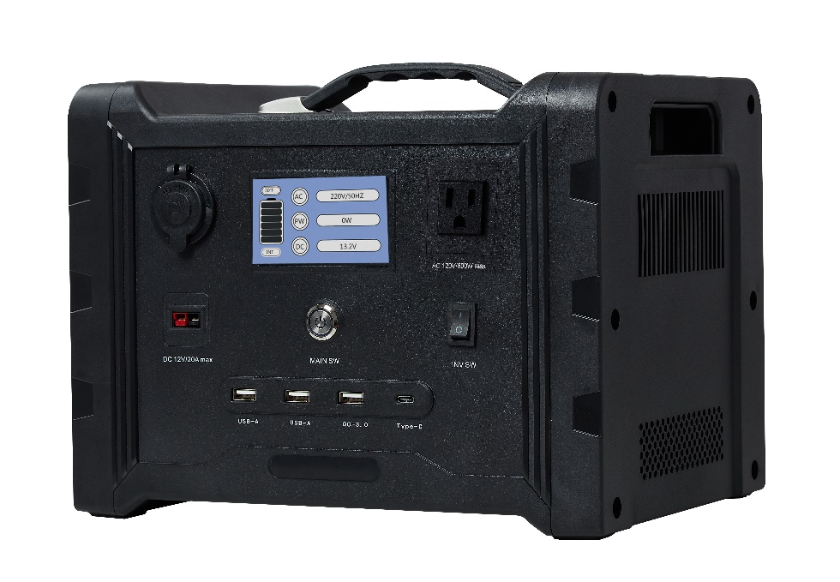

USER'S GUIDE

600W Portable Power Supply System

Before using this unit, please read ALL instructions and information in this user manual.

CONTENTS

ABOUT THE PORTABLE POWER SUPPLY SYSTEM.................................. 2

SYMBOLS AND TERMS ................................................................................ 3

SAFETY INSTRUCTIONS .............................................................................. 4

GETTING STARTED ....................................................................................... 5

UNIT OVERVIEW ............................................................................................ 6

INTERFACE .................................................................................................... 6

TECHNICAL SPECIFICATION………………………………………………….13

MANUFACTURER WARRANTY INFORMATION ......................................... 15

Please read this entire manual before attempting to use this product.

WARNING

1. Avoid dangerous environments. Do not charge this item in rain, snow or other damp environments. Do not use this item or charger in the presence of explosive atmospheres (gaseous fumes, dust or flammable materials) because sparks may be generated when charging or discharging this item, possibly causing fire.

2. Charge in a well-ventilated area. Do not allow smoking or open flames near a charging battery. Vented gases may explode. Caution when charging outdoors; surface of generator may get very hot. Handle with care.

3. Do not burn or incinerate this item. This item may explode, causing personal injury or damage. Toxic fumes and materials are created when batteries are burned.

4. Do not crush, drop or damage this item. Do not use this item if it has received a sharp blow or has been dropped, run over or damaged in any way (e.g., pierced with a nail, hit with a car, etc.).

5. Do not disassemble. There are no serviceable parts. Disassembly increases the risk of electric shock, fire and exposure to battery chemicals that may cause personal injury or damage.

6. Battery chemicals cause serious burns. Never allow battery chemicals into contact with skin, eyes or mouth. If this item leaks battery chemicals, use rubber or neoprene gloves to dispose of the leaked chemicals. If skin is exposed to battery fluids, wash with soap and water and rinse with vinegar. If eyes are exposed to battery chemicals, immediately flush with water for 20 minutes and seek medical attention. Remove and dispose of contaminated clothing. Do not inhale vented fumes or smoke. Please contact the manufacturer immediately for instructions on returning or disposing of the defective unit.

7. Do not short-circuit. This item will short-circuit if a metal object makes connection to the AC or DC output ports. Do not place this item near anything that may cause a short circuit, such as coins, keys or nails. A short-circuited battery may cause fire and personal injury.

8. Never charge or jump-start a frozen battery.

9. Store this item in a cool, dry place. Do not store this unit for more than 10 days in an environment where temperatures may exceed 120 °F (49 °C), such as direct sunlight, a vehicle or a metal building during the summer. Doing so may cause damage to the unit.

10. This product is not intended for commercial applications.

Before using this unit, please read ALL instructions and information in this user manual.

ABOUT THE PORTABLE POWER SUPPLY SYSTEM
The Portable Power Supply System is a seamless solution that protects you when outages leave you powerless for an extended period of time. The quiet, portable device is all about practicality and endurance, lasting for 3,000+ life cycles. Other system try, but none can match the power of the portable power supply system and still offer all of the following:

Safety:
No emissions — none. Unlike fossil fuel powered generators and lead-acid batteries, the Portable Power Supply System has no carbon footprint, emits no greenhouse gases and causes no damage to the environment. It’s even safe enough to use indoors.

Quiet:
The protected lithium core produces wattage without the loud, continuous sound made by other gas or diesel generator engines.

Renewable:
Powered and replenished by natural resources such as the sun, wind and water, as well as mechanical devices. Unit retains charge for one year.

Portable:
The Portable Power Supply System is a relatively small device measuring just over a cubic foot and weighing only 8.5kg. That’s small enough to carry or store just about anywhere. Most generators surpass this weight by more than double yet offer less power.

Affordable:
No other generator offers the same quiet power output and device versatility for the same value.

SYMBOLS AND TERMS

Important Symbols

The following symbols are used in this guide:

WARNING

Warnings are conditions and practices that could result in personal injury.

CAUTION

Cautions are conditions and practices that could result in damage to the unit or other equipment.

Important Terms
The following terms are helpful for you to know and are used in this guide:

Term | Definition
A | Ampere or amp
Ah | Amp-hour
AC | Alternating current
DC | Direct current
Hz | Hertz
kW | Kilowatt; one thousand watts
kWh | Kilowatt-hour
LED | Light-emitting diode
mA | Milliampere; one-thousandth of an ampere
PV | Photovoltaic
VAC | Volts AC
VDC | Volts DC
W | Watts
Wh | Watt-hour

Additional Information

You can find additional information about this product at www.dm-tech.com.cn

SAFETY INSTRUCTIONS

WARNING

This section provides important safety and operating instructions. Any improper use of the system can result in serious injury and possibly death in extreme situations.

CAUTION

Check with manufacturer of medical devices before powering any life-support systems or other medical equipment to ensure they are compatible with the power supplied by the Portable Power Supply System.

CAUTION

Check with tool and/or equipment manufacturer before powering any of their products to ensure they are compatible with the power supplied by the Portable Power Supply System.

1. Before using your unit, read ALL instructions and information in this user manual.

2. To prevent overheating, provide a minimum of 6 inches of clearance on all sides of the unit. Take special care not to cover or obstruct the cooling fan or exhaust vents located on each side.

3. When using this unit outdoors, maintain the 6-inch clearance, but shelter the System to prevent rain, snow, dust, dirt, loose debris and other particles from entering the System. Such particles present a fire hazard.

4. You may simultaneously connect up to 2 DC loads and up to 1 AC loads within the parameters enforced by the limits on page 13.

5. To reduce the risk of electrical shock while cleaning the unit, disconnect all inputs and power off the system. SWITCHING OFF ALL POWER DISCHARGE PORTS WILL NOT ELIMINATE RISK. TURN OFF MAIN POWER SWITCH.

6. Inspect all power cords and connectors before attempting to connect them to your system. If cords are frayed, burnt, or otherwise damaged, DO NOT connect the cord to your system. Using damaged cords or connectors increases the risk of fire and electrical shock.

7. DO NOT use if your unit has been dropped or damaged in any way. If unit is damaged, contact us for next steps (information on back cover).

8. DO NOT attempt to disassemble the system. There are NO serviceable parts in the unit, and opening the system can expose the user to internal components that could cause severe injury or death. Opening the system is very dangerous and WILL VOID THE WARRANTY.

9. Repairs should be done ONLY by a qualified repair technician.

GETTING STARTED

Thank you for your purchase of the Portable Power Supply System. The 600-watt pure sine wave AC inverter output in this unit makes it compatible for use with many of today’s high-tech electronic devices. It also allows appliance motors to operate more efficiently and at cooler temperatures.

Be sure to carefully read this user manual. Even though your Portable Power Supply System has many advanced, built-in safety features, it is still important to take some time to become familiar with the Safety Instructions on page 7 of this guide before operation.

If you still have any questions, please contact our support team. See Contact Information on page 2.

UNIT OVERVIEW

You should have received the following items with your power supply system:

- Unit
- Adapter with AC cord
- User manual
- Carry bag
- Anderson cord (1 side with Anderson port)
- Battery extension cord (with connector)

INTERFACE
Cigarette Lighter output

LCD screen
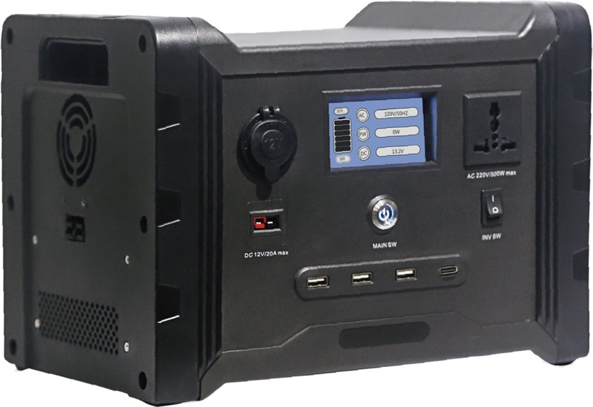

AC Output

Main Power Switch

Inverter Switch

3* USB 2.0 and 1 USB-C PD output

Anderson 20A output
Extension Battery port

Unit front side

Embedded handle
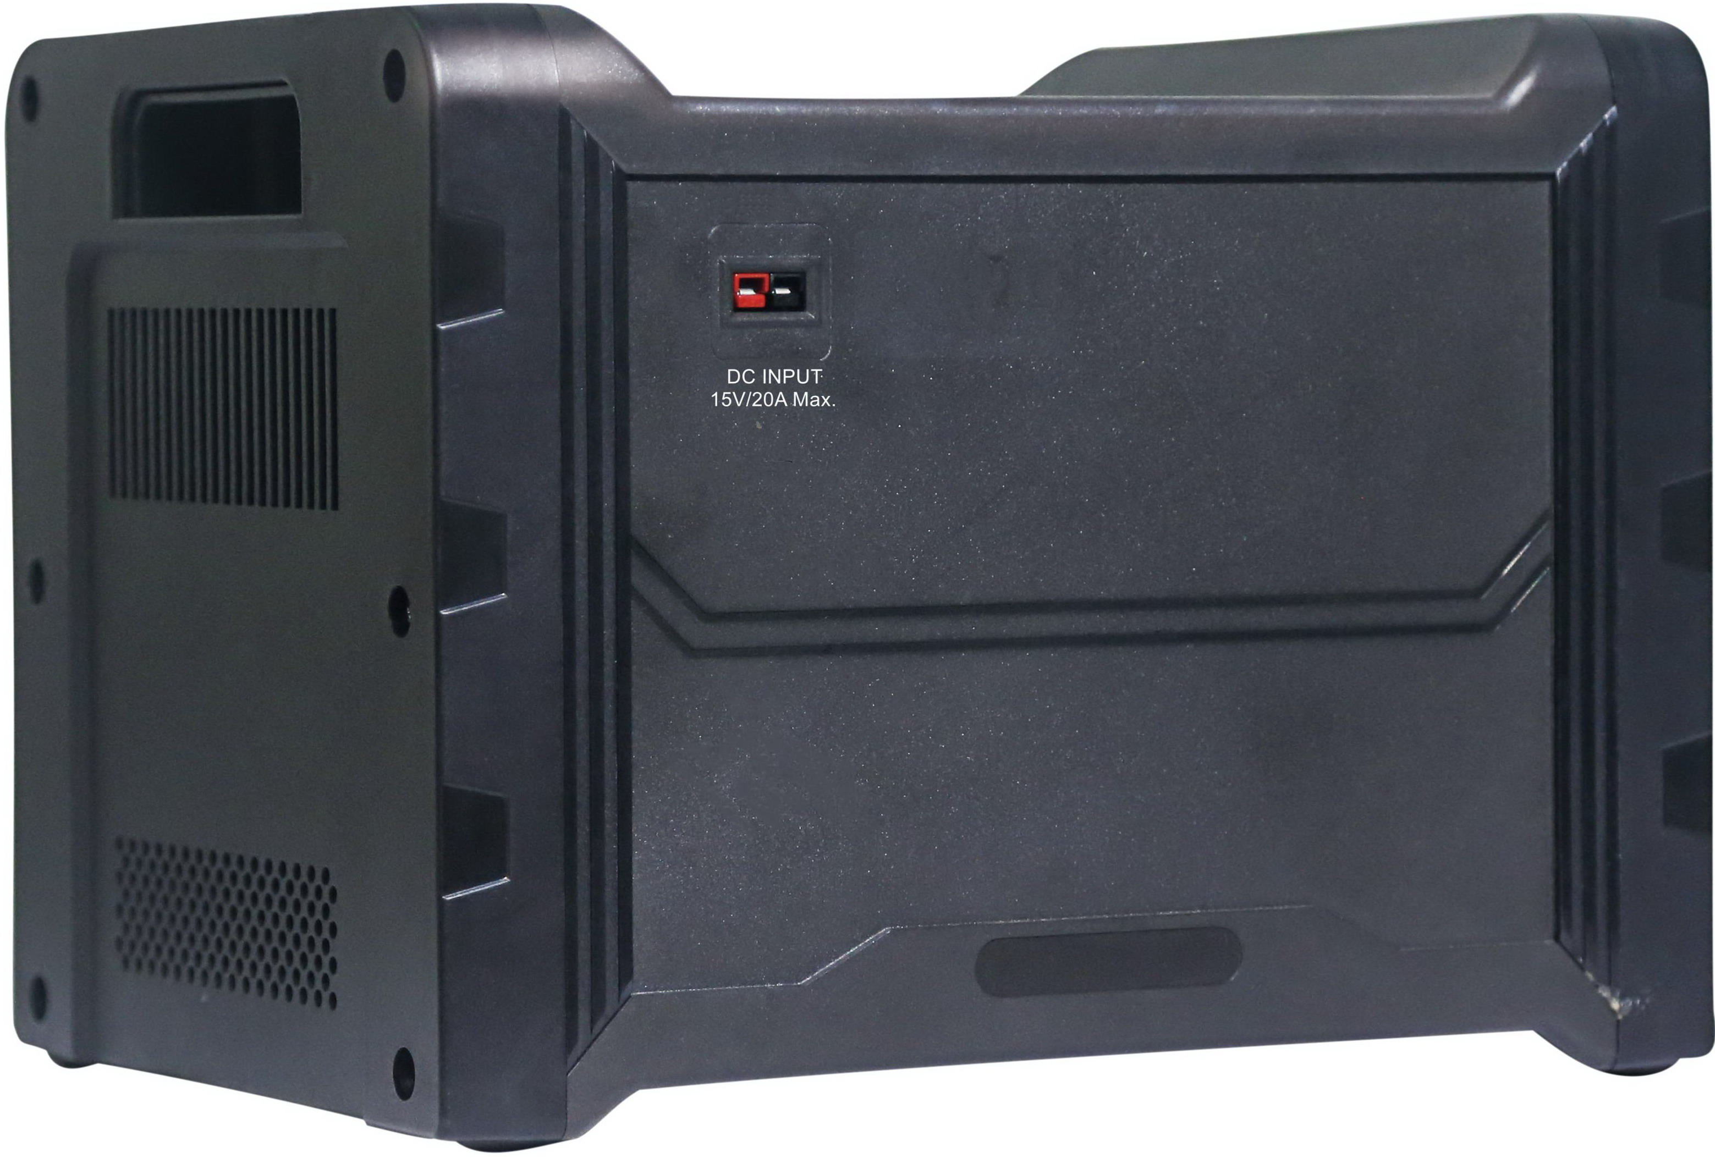
Adapter and DC Input

Unit front side
Unit Back side
Interface description

1. No external battery

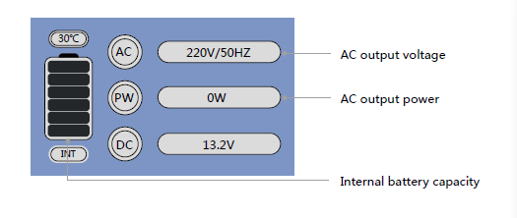
2. With DC Output

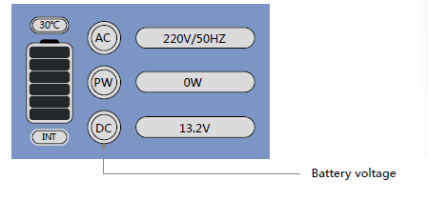
3. Connect an external battery

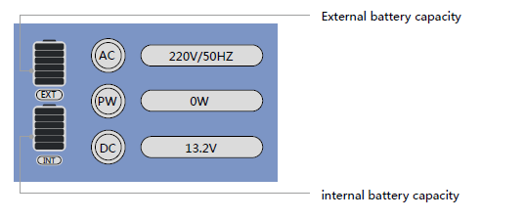
Charging
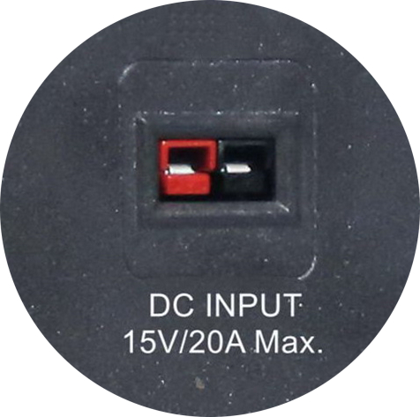

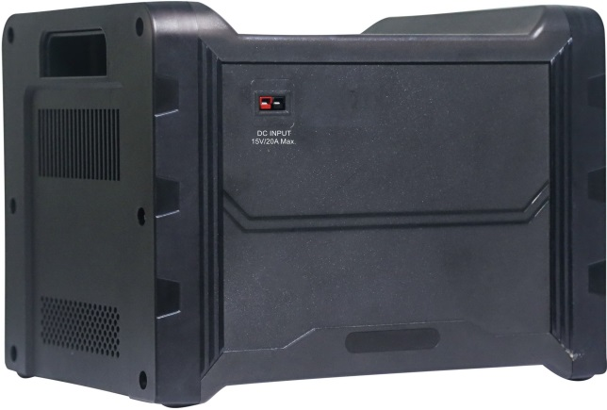

WARNING

Check adapter and cord for damage prior to use. Never use a damaged or frayed cord; electrical shock can occur if cord is damaged or frayed. If damaged, replace with a new one before proceeding with AC usage (request replacements via Contact Information on back cover). Improper charging may result in serious injury and or death.

Adapter Input

AC input voltage: 100V-240V

Rated output parameter: 15V/20A

Solar Input
17-23V Solar panel, 300W Max

1. Charging your unit via adapter:

• Plug the provided adapter into the back of the unit (see photo); then plug the cable into an AC wall outlet.

• While unit is charging, a flashing lightning bolt will appear in the top left-hand corner of the LCD screen on the front of the unit.

• Once the unit is fully charged, the lightning bolt will stop flashing; all 6 bars of the battery indicator will be full.

• Wait 10–15 minutes for the cells to settle. If you notice the battery indicator drop down to 5 bars, reset the unit by pressing the key to the turn off position and then restart the unit. This will turn the charger back on so it can fill up the balanced cells.

• When your unit is fully charged, turn off the unit. Then remove plug from wall and back of system.

2. Charging your unit via DC source:

1. Plug the provided Anderson extension cable into the back of the battery box (see photo); then plug the cable into the output of your charging source (for example, solar panel, hand crank, windmill, etc.).

2. While unit is charging, a flashing lightning bolt will appear in the top left-hand corner of the LCD screen on the front of the unit.

3. Once the unit is fully charged, the lightning bolt will stop flashing. All 6 bars of the battery indicator will be full.

4. Once the unit is fully charged, wait 10–15 minutes for the cells to settle. If you notice the battery indicator drop down to 5 bars, reset the unit by pressing power key and then back power on the unit. This will turn the charger back on so that it can fill up the balanced cells.

5. Once the unit is fully charged, power off the unit and disconnects the cables. Attention: This unit will accept ONLY 12-volt DC sources. If any other VDC is used, the unit will be damaged.

3. Never leave your unit unattended for a long time while it is charging.

4. Never store your unit in a charging state.

5. If the unit is plugged into an AC outlet at the same time it is being used to power an AC device, the unit will continue to function as normal discharge and charge during use. Under this condition, the unit temperature would be very high, please don’t load with 600W power electronics on the unit while charging.

AC Usage Outlets

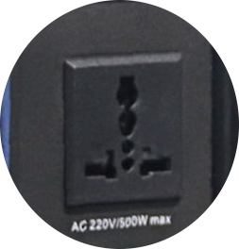

WARNING

Never use a damaged or frayed AC cord; electrical shock can occur if AC cord is damaged or frayed. If AC cord is damaged, replace with a new cord before proceeding with AC usage (request replacements via Contact Information on back cover).

• To use your AC outlets, plug in the devices you want to run. Then turn on the inverter by switching the main AC power switch (see photo) to the ON position. Once on, the outlets will work like normal AC wall outlets in your home.

• In order to protect the inverter and battery, any sustained discharge over 600w will cause the unit to shut down. It can subsequently be reset.

• The watt meter, found on the bottom row of the LCD display, shows the amount of energy being used by the inverter. Please note this energy output is an estimation, and actual output may vary from displayed values.

• Because the watt meter measures inverter output, it will show wattage only for loads plugged into the AC output ports. This meter will never display energy output from DC ports.

• The watt meter cannot detect loads accurately under 25 watts and will display 0 watts for loads under 10 watts.

DC Usage Outlets

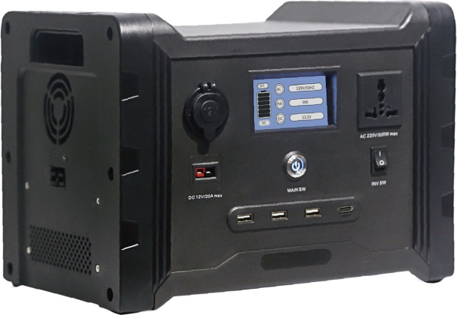
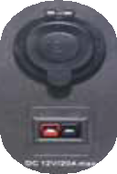
WARNING

Never use a damaged or frayed DC cord; electrical shock can occur if DC cord is damaged or frayed. If DC cord is damaged, replace with a new cord before proceeding with DC usage (request replacements via Contact Information on back cover).

How you use the DC

Anderson Powerpole outlets (see photo) depends on the amperage of your chosen load. For loads between 0 and 20amps, you will need an Anderson Powerpole extension cord. First, plug the extension cord into the desired device. Then, plug the other end of the extension cord into the Anderson Powerpole outlets on the front of the system (plug black into black and red into red).

To use the DC cigarette outlet (see photo), simply plug in any 12-volt device that is rated for a maximum of 10 amps and operate as normal.

Please check with your device manufacturer for proper power requirements and compatibility.

DC USB Outlets

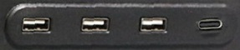

To use your USB outlets, first plug the device you want to use into the appropriate outlets– USB 2.0 with 5V/2.1A Max., USB QC3.0 18W Max., USB-C 60W Max.
Connect with extension battery
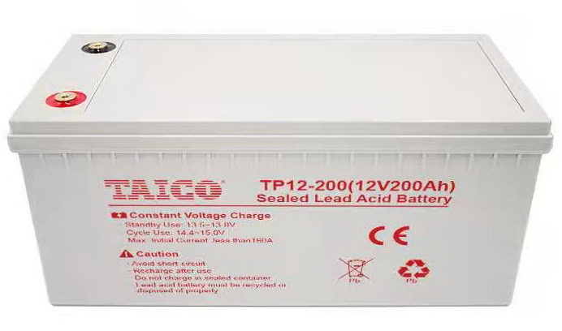

1, Plug the provide extension battery cable into the 600W unit, then connect the other side to the battery you want to connect;
2, the unit could connect with ANY 12V battery (AGM, Lead Acid, Lithium battery); whenever connected, it functions as if you had two internal batteries.
3, Outputs will drain the external pack first. Once the external pack is empty, it will immediately switch to using the internal battery.
4, Do not try to charge the external pack separately from the system.

TECHNICAL SPECIFICATIONS
Dimensions: 29.5 L*22.5 W*22 H (cm)
Weight: 8kg
Operating Temperatures: 23°F–111°F (-5°C–45 °C)
Operating Conditions:
- Keep out of rainy, damp, or snowy conditions.
- When charging outside with a solar panel, use the panel to shade the unit for better charging efficiency.
- Do not store in a hot vehicle for extended periods of time (i.e. anything over 5 hours).

Battery:
- Lithium Iron Phosphate (LFP)
- 40Ah (512Wh) capacity
- 12.8V capacity
- Rated for 2,500+ charge and discharge cycles
- Minimum charge time: 2.5 hours
- Charge retention: 1 year (85%)
- Integrated inverter: 120V AC pure sine wave; 600W continuous output, slow-start feature protects the inverter from over-current draw;
- Maximum of 20A @ 12V charging current from DC circuitry
- Maximum combined charge from AC and DC circuitry: 20A @ 12V DC Max
- DC output current: 20A;
- Prismatic cell geometry

Unit Body:
- Plastic case
- Cooled by back-mounted fan

LCD Display:
- 6-bar battery-shaped gauge
  - Always on so you always know when your battery is charged
  - Displays wattage used while the AC switch is on for easy run time calculations. Will remain at zero when AC switch is in OFF position

Power Controls:
- Power key on front panel
- AC power ON/OFF switch on front of unit

Input Ports:
- DC: AC adapter, 15V/20A, 100-120V/220-240V;
- DC: Anderson Powerpole connector ports; 1 set, total of 20A limit using 12V input; support 17-23V 300W (max.) solar panel;

Output Ports:
- AC: 110-120V, 50Hz; 1 outlet total current limit of 600W, including a slow-start feature that protects the inverter from over-current draw;
- DC: 2*USB 2.0 outlets, 2.1A /10.5W Max; 1 USB QC 3.0 18W Max.; 1* USB-C PD 3.0 60W Max. outlet (5V/3A, 9V/3A, 15V/3A, 20V/3A)
- DC: Anderson Powerpole connectors; 1 set with a total shared current limit of 20A @ 12VDC (240W max output)
- DC: 12V cigarette lighter adapter capable of 10A (120W) max output;
- Extension battery port: connect with any 12V battery;

What in the package:

- 1*600W Portable Power Main unit;
- 1* 14.6/20A AC adapter charger with AC input cable (AU, EU, USA etc.)
- 1* 70cm Anderson cable

MANUFACTURER WARRANTY INFORMATION
2-year from the date of delivery:

What is covered?

Defects in materials or workmanship.

Non-cosmetic, normal wear and tear related damages.

Units authorized for return. To receive authorization, please contact our customer service team (see Contact Information on page 2). We will assign a return merchandise authorization (RMA) number and arrange a scheduled pickup. Under no circumstances should you return a unit without prior authorization. Authorized returns are not subject to a restocking fee.

Warranty restarts with replacement unit.

What is not covered?

Damage or defect caused willfully or through negligence. Damage caused through excessive wear and tear.
Cosmetic blemishes, scratches, or dents acquired through the course of regular use.

Damage caused by use of the unit with unsafe, unregulated or inappropriate products, devices, power sources or power consumption.

Damage resulting from use of the product for anything other than what it is intended for. This warranty does not cover damage caused when the unit is used as a footstool, wheel chock, doorstop or flotation device (it does not float, is not waterproof and may cause bodily injury or death if used as a flotation device).

Any return not previously authorized by our team. Unauthorized return shipments will be rejected or restocked without notification to the sending party.

Upgrade to a newer model. All damaged units will be replaced with a unit of the same model that was originally purchased.

Additional Terms:

Damage caused willfully or by negligence will void the warranty at any point in the 365-day period. Willful or negligent damage is determined upon receipt and inspection of the unit. All refunds/returns will be processed after inspection for willful or negligent damage.

Any unit that has been altered or repaired by an unauthorized service is voided of any warranty.

All products must be returned with all included attachments and accessories unless otherwise directed when obtaining an RMA number. The customer will be billed/ charged for any missing attachments or accessories.

If proof of purchase, purchase order, receipt or record of purchase is not available upon request, we will not be responsible for any warranty service.

Any returned unit must be packaged safely and labeled clearly. Any damage caused by poor packaging when returning the unit is the responsibility of the customer and may void the warranty.

Customers should keep a record of the serial number of any unit sent in for replacement. To facilitate the return process, clearly write the serial number on the shipment box as well.

Products that are not authorized for return as per the RMA will not be accepted.

At our discretion, units will be repaired or replaced.

If the customer sends a unit in for repair and it is found to be free of defect or damage after inspection, the customer will be responsible to pay a $50 service charge, actual handling and shipping costs to and from our facility and any other necessary costs incurred during processing.

