**Installation of twin 175W semi-rigid solar panels over dinghy davits**

*Ian McMahon, August 2021*

**Postscript, August 8, 2021**

For the past three weeks Brenna has remained unplugged from shore power at and away from her slip, her house batteries have remained fully charged, and our Honda 2000i has been returned to our home ashore. We have left the dock for a 2-day weekend and a 4-day weekend. Both involved some motoring and time at anchorage. Brenna’s house batteries SOC rarely dropped below 13V. Admittedly, this is high summer, but so far, our experience could not have been better.

**Custom Marine Products**

Custom Marine Products, Southeast Michigan, specializes in solar power generation and lithium batteries for boats and has been providing leading edge marine solar solutions worldwide since 2010. Its product research and development, manufacturing and customer service are among the best in the industry. Tom Trimmer’s goal is to work with customers to design and deliver a high-quality solar system and integrated battery power system that will best meet their boating needs at a fair price.

Custom Marine Products website has a wealth of educational content on its Product, Blog and Support webpages. In addition, Tom Trimmer has posted educational YouTube videos. These resources were very helpful for my project planning.

<https://www.custommarineproducts.com/>

Tom Trimmer at [info@custommarineproducts.com](mailto:info@custommarineproducts.com) or 248 710 0567.

**Project Planning**

The objective was to install solar panels on Brenna, a Sabre 452 sloop, sufficient to provide power independence at anchor and under passage. Brenna has two Lifeline 12-V 8D AGM for its house batteries. A dedicated engine starting battery is on a separate circuit.

Brenna does not have a Bimini and her boom extends over the dodger creating a large sun shadow. Brenna does not have much useable deck space. Brenna’s does not have an installed generator, though we carry a portable Honda 2000i aboard as a backup. Her biggest power draw is navigation equipment (PC, chart plotter, instruments, autopilot, radar), a single Sea Frost cold plate, various pumps (water pressure, vacuum flush heads), anchor windless, and LED lights (saloon, navigation). The Yanmar engine has a Balmar high output alternator to charge the house batteries. We concluded that two 175W black semi-rigid panels mounted over the dinghy davits would be the best solution, provided one can easily see over or under them when one is standing or seated in the cockpit. The output from 350W of solar panels should be sufficient to maintain the house batteries state of charge at a sufficient level and reduce the need to run the Yanmar engine specifically to charge the batteries.

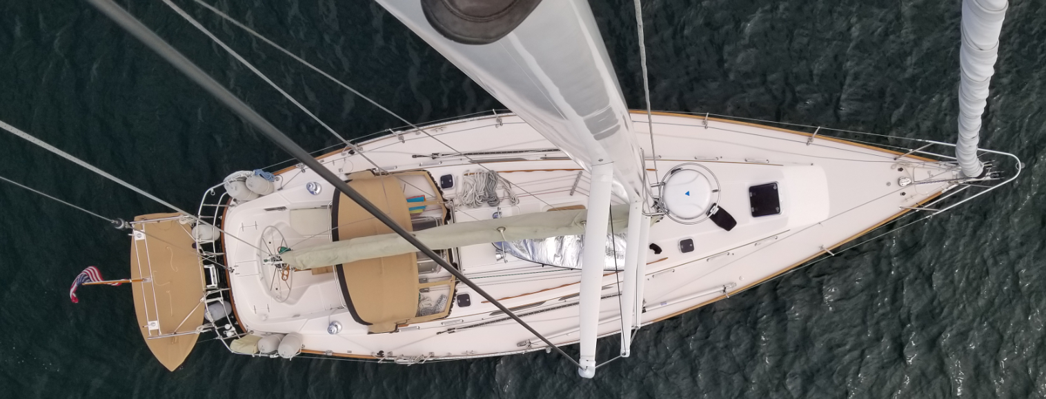

**Solar panels**

The following items were provided by Tom Trimmer, Custom Marine Products.

* 175W semi-rigid solar panels
* EPEVER MPPT DuoRacer Solar Charge Controller
* 50’ of 10AWG cable. This was cut in ½ for two 25’ positive and negative cables
* Temperature sensor to be taped to the battery positive cable to avoid overheating/overcharging
* J-extrusions for securing the solar panels to the rectangular aluminum tubes

The following parts were provided by Kato Marine, Annapolis, Maryland, specializing in finely finished, high quality stainless and aluminum custom fabrications for the marine world.

<https://katomarine.com/>

7416 Edgewood Road, Annapolis, MD 21403. Phone: 410-269-1218

[vicki@katomarine.com](mailto:vicki@katomarine.com)

* Stainless steel Risers for Kato Marine dinghy davits SS100 stabilizer bar
* Western Extrusions rectangular 2” x 1” x 0.125” anodized aluminum tubing (36.4” x 2 and 77.5” x 3)

**Aluminum frame for the solar panels**

To ensure the weight of the frames and panels is perfectly balanced, and their tilt is easily adjusted using the risers oversized butterfly nuts, the panes and frame should be centered over the risers.

The frame consists of four rectangular 2” x 1” anodized aluminum tubes. Two fore/aft tubes, corresponding to the width of a solar panel (36.4”), were bolted to the s/s risers, and two port/starboard tubes, corresponding to twice the length of a solar panel (37.6” x 2) plus a little extra room in the middle for the flagpole, or 77.25”, were bolted to outer edges of the fore/aft tubes.

I purchased a third port/starboard tube (not shown) to support the solar panels in the middle.

To attach the tubes to the risers, use s/s hexagonal head bolts with 5/16” diameter x 1-1/2” length, with a 5/16” flat washer on the top, and a 5/16” split washer and 5/16” wing nut on the bottom. A hex key is easier to tighten/loosen bolts than a spanner and a wing nut can be tightened and loosened by hand. Drill 5/16” holes using a tungsten drill bit.

To attach the top (port/starboard) tubes to the bottom tubes, s/s carriage bolts with 1/4” diameter x 2-1/2” length, with a 1/4” split washer and a 1/4” wing nut on the bottom. Carriage bolts have a low-profile dome shaped top and a square neck. After drilling the 1/4 hole through the tube, hammer the carriage bolt flat into the tube to set the bolt’s square head into the top side of the tube, which will prevent the bolt from turning when you tighten the wing nut on the bottom.

|  |  |  |
| --- | --- | --- |
|  |  |  |

I set aside the third horizontal tube with the intention of installing it later, assuming everything worked as planned.

The panels are attached to the tubes using J-extrusions provided by Custom Marine Products that go on either side of the panel. The J-extrusions are attached to the rectangular aluminum tubes with double sided 3M Very High Bond (VHB) tape. Notch the J-extrusions to fit around the heads of the carriage bolts, apply the tape to the J-extrusions and attached them to the tubes.

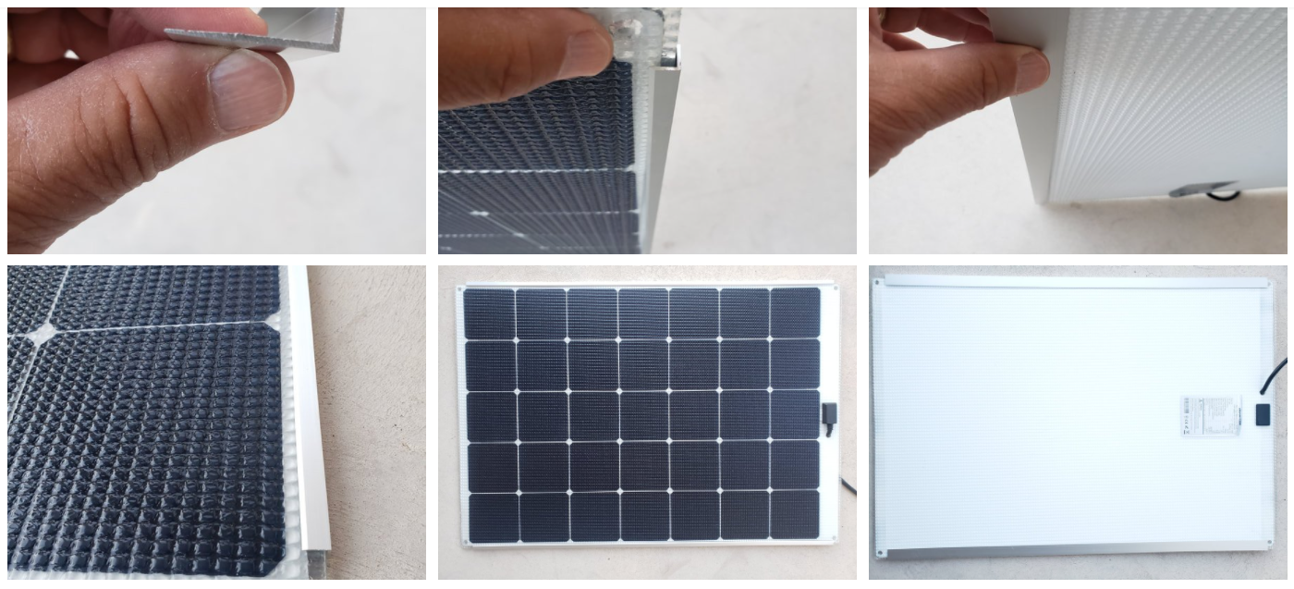

*Source: Custom Marine Products*

Lift the solar panel into place, sliding it into the back J-extrusion, and loosening the wingnut on the front tube to back it off to fit the front J-extrusion over the panel, and then retighten the bolt. The panels slid easily into the J-extrusions and can be easily removed for winter storage by one person. To stop the panels from sliding out of the J-extensions, attach 2” lengths of J-extrusions across the outside ends of the tubes.

To give the tubes a finished look and keep water put, insert black plastic 2” x 1” end caps. The end caps were a little tight for the thick walls of the tubes. Use a sharp knife to trim the excess plastic from the 1” ends of the caps and tap into place with a rubber mallet.

**Additional Items needed**

* 5/16” diameter x 1-1/2” bolts with hex heads, 5/16” flat washers, 5/16” split washers and 5/16 wing nut (4 of each plus spare split washers and wing nuts in case I drop one overboard), to attach the cross bars to the stabilizer risers. (True Value Hardware, Mystic, CT)
* ¼” diameter x 2-1/2” carriage bolts, 1/4” split washers and ¼” wing nut (6 of each, plus spares) to attach the panel support bars to the top of the cross bars. (True Value Hardware, Mystic, CT)
* 3M 1 Inch Width 15 Ft Length VHB 5952 Black Heavy Duty Multipurpose Double-Sided Tape. Black 0.045 in (1.1 mm). (Amazon.com)
* Plastic end caps for 2” x 1” rectangular aluminum tubes. (Amazon.com)

**Tip**

To drill holes in the aluminum tubes I used an electric drill with power chord (more torque than a battery drill) and tungsten steel drill bits. Aligning the top and bottom holes vertically and horizontally in the rectangular aluminum tubes is a challenge without a drill press, and I messed up a few before realizing the issue. My solution was to wrap paper masking tape around the tube, aligning the tape so that diagonal lines (marked with a ruler) from the corners intersect the placement of the hole in the center, and replicating the diagonal lines on the other side. Drill a hole through one side, turn over the tube and drill a hole through the other side. After the holes in one tube are perfectly aligned, use it as a guide to drill top/bottom holes in the other tubes. Of course, had I though of bringing a block of wood with a perfectly aligned hole, it would have saved me the bother of taping.

**Installing the Controller**

The solar charge controller was mounted in a well-ventilated equipment cabinet in the salon next to the navigation station and house battery bank. The cabinet also houses a 40-amp Xantrex shore power charger and beneath the cabinet is a locker with Xantrex Freedom Invertor/Charger, whose inverter works but charger does not. The equipment cabinet was specially designed by Sabre with lots of holes to ventilate the Freedom Invertor/Charger and with wiring holes, and the cabinet door is louvered. The cabinet originally housed a cathode ray TV/VCR. Remember those?

**Solar Charge Controller to Batteries**

The DuoRacer Solar Charge Controller is powered by the battery bank and feeds power from the solar panels to the batteries.

Wiring the controller to the batteries needs a thorough planning to get all the materials needed and properly size the wire. I decided to use 8 AWG (10.0mm) wire to connect the controller to the house battery bank, because 10 AWG (6.0mm) wire was provided to connect the solar panels to the controller.

Connect the 10 AWG red (positive) and black (negative) to the controller and run them to the battery box. Mount a 40-amp battery circuit breaker and connect the red (positive) from the controller to the circuit breaker. Use a second length of 10 AWG red (positive), attach a proper sized a battery lug and connect it to the positive battery terminal. Hold off attaching the cable until later.

To determine the size of the fuse needed for the solar system, use the following calculation provided by Tom Trimmer, Custom Marine Products: Watts of solar /12V (or 24V) = amps + 10 amps. Brenna = 350W / 12V + 10A = 40-amp fuse. Per Tom, many controllers have a built-in fuse as a secondary protection. However, adding the external circuit breaker protects against a short circuit overheating the wires to cause a fire, such as a loose cable connection, and a power surge in the event the panels are struck by lightning.

Brenna has a Blue Sea VMS battery monitor and the negative 10 AWG black wire from controller was connected to the house side of the Blue Sea battery monitor shunt, rather than to the battery bank, after attaching a proper sized a battery lug to the cable.

Connect the controller’s temperature gauge to the controller, run it to the battery box and attach it with electrical ties to the negative battery cable.

Connect the 8 AWG ground cable (green) to the controller and the other end to a suitable ground. I used the hull’s copper tape ground system as conveniently there was a piece of it behind the navigation desk that used to ground a former SSB controller.

This completes the wiring of the controller to the house battery bank.

**Items needed**

* 40-amp battery circuit breaker
* 8-gauge red cables to connect (1) controller to 40-amp circuit breaker and (2) 40-amp circuit breaker to battery terminal.
* 8-gauge black cable to connect controller to house side of the Blue Sea battery monitor shunt
* 8-gauge battery lugs x 4. Two large to the battery (red) and shunt terminal (black) connections and two small for (red) circuit breaker connections
* 8 AWG ground cable (green)

**Solar Panels to Solar Charge Controller**

Wiring the controller to the panels also needs thoughtful planning to get all the materials and properly size the wire. Each panel came with 2.5mm duplex wire (brown = positive; blue = negative), rather than MC4 positive and negative connections supplied with most panels.

Connecting the Controller

The first task was to run the black 10 AWG cable provided by Custom Marine Products through Brenna’s cable ducts from a cockpit locket at the stern to the equipment cabinet with the controller adjacent to the navigation station. Custom Marine Products provided a 50’ length of cable with positive and negative MC4 connectors at its ends. I cut the cable in half, labeled the end of the positive cable with masking tape, and pulled both 25’ cables through the ducts.

Connect the black negative 10 AWG cable for the panels to the controller’s negative battery terminal.

Connect the black positive 10 AWG cable for the panels to a 10A circuit breaker and connect the circuit breaker to the controller positive terminal with another length of 10 AWG wire. I installed the circuit breaker in a surface mounted breaker box next to the controller. Per Tom Trimmer, this will allows you to turn off the solar panels when running the engine so the high-output alternator can charge the house batteries efficiently.

To calculate the capacity of the circuit breaker switch Tom Trimmer provided the following useful formula: Watts of solar / VOC (open circuit voltage) = amps. Brenna = 350W / 34.7Voc = 10 amps. Note the much lower amperage on the solar side of the controller vs the battery side of the controller. Panels never surge power unless hit by lightning.

This completes the connections at the controller. The next task is to connect the two solar panels to the positive and negative 10 AWG cables in the stern locker.

Connecting the Solar Panels

Many solar panels are pre-wired with separate positive and negative cables fitted with MC4 connectors. Instead, each of the 175W semi-rigid panels was wired with a duplex cable containing two 2.5mm wires (14 AWG), with brown = positive and blue = negative. Tom recommended connecting the panels in parallel.

Initially, as suggested by the wiring diagram, I intended to connect each panel to a 3-way junction box to separate the positive and negative wires, attach MC4 connectors to the outgoing wires, and use 2-to-1 MC4 junction boxes to join the four wires (two positive and two negative) together and attach the MC4 cable connectors from the controller. I bought all the parts need for this configuration. Then, after looking at all the wiring on installation day I thought of a more efficient wiring schematic: simply join the panels duplex wires together and join a single duplex cable to the MC4 cable connectors from the controller.

I joined each panels duplex cable containing two 2.5mm wires (14 AWG) together using a 3-way junction box and attached a 25’ length of duplex cable containing two 6.0mm (10 AWG). I decided to use the largest gauge that would fit into the terminal block.

I made this cable long enough so, at the end of the season, I can remove the panels from the frame and stow them in the cockpit resting against the wheel without having to disconnect any of the wiring.

I fed the single duplex cable through a transom cowl (also used for other wires) into the stern locker. There I connected the end of this cable to a second 3-way junction box, connected a red/positive 10 AWG wire to the positive connection in the second terminal, and connected a black/negative 10 AWG wire to the positive connection in the third terminal. Lastly, I connected MC4 connectors to the ends of the positive and negative cables.

The final task was to connect the positive/red battery cable from the controller (to power the controller) and connect the solar panels positive and negative MC4 connectors to the controller (to feed the controller with the sun’s energy). Everything worked perfectly and the controller and panels were operational.

**Items needed**

* 25’of duplex 10 AWG cable (red/black)
* 2’ each of 10 AWG cable (positive and negative)
* 1’ of 10 AWG cable to connect the 10-amp circuit breaker to the controller
* Two 3-way junction box (Amazon.com)
* One MC4 positive connector
* One MC4 negative connector
* Blue Sea 10-amp panel circuit breaker (to turn off solar panels)
* Blue Sea surface mounted housing for circuit breaker switch

**Results**

To test the system, I switched off the inverter and disconnect the shore power. Brenna’s only power draw was from the Sea Frost cold plate refrigeration. When I returned early the following Saturday, the sun was shining, the controller was sending 8A to the house batteries, and they were almost fully charged. A short while later the controller’s output dropped to 1A, indicating they were fully charged. We are delighted to have power independence at last. We may only need shore power in the Spring and Fall to run an electric heater or make hot water. The total investment was a fraction of the cost of installing a generator, not to mention its noise, the loss of space below, the necessity to change oil and filters, and its pollution. Instead, the environmentally friendly low-profile panels are hardly noticeable over the dinghy and improve Brenna’s aesthetic appearance.

**Wiring Diagram**

**Appendix**

**When and how to Shut Down Your Solar System**

A solar system will typically be putting out 10-30 amps to the battery bank. An alternator will typically be putting out 45 - 200 amps to the battery bank. You want everything you can get from the alternator when the engine is running. Sometimes, on some boats, the alternator will sense the net voltage of the battery bank plus the voltage from the solar controller and see a higher voltage than the actual voltage of the battery bank. This may cause the alternator to prematurely go into the float charge phase which is low amps. Thus, the batteries are not getting the full charge from the alternator. When this happens, you use the switch between the solar array and the controller to turn off the solar to get full power from the alternator.

How do you know if the alternator is going into float mode prematurely? You see it on the amp meter or the battery monitor if the boat has one. Otherwise, it is difficult to tell. This is the only reason to shut off solar with the switch. The switch is between the solar panel and the controller because the controller is powered by the battery, not the solar panels and you want to keep power to the controller rather than reboot it all the time.

There is no harm in having solar, generator, shore power or alternator connected at the same time. Another consideration: If the batteries are low, it is unlikely the net of the battery voltage and the solar is enough to move the alternator to float mode. This only happens when the batteries are nearing full charge and it is midday and the solar is putting out a full charge. It happens on our boat only under these conditions. Then there is the difference in charging voltage of lead acid and LiFePO4 batteries. It would seem more likely to happen with LiFePO4 batteries since the charge curves are at a higher voltage.

**Use the proper size wire between your MPPT solar controller and battery bank**

One of our customers was getting less than 20% of the rated power from his solar panels and he called us for help. He had 400 watts of solar, was using a Victron MPPT controller and two CMPower 120 Ah LiFePO4 batteries. He should have been getting 25+ Amps of charging power from the controller to the batteries but was only getting 4 Amps. We spent several hours troubleshooting; charging and discharging the batteries, testing the solar panels reprogramming the MPPT controller all to no avail. He texted me a picture of his installation and happened to mention he was temporarily using a 25 foot long 12-gauge wire between the controller and the batteries. I suggested he try a short 10 or 8-gauge wire and see what happens. Magically, the system began to work perfectly. I reproduced the same situation in our shop and achieved the same results. The bottom line: The wires between the controller and the battery bank MUST be adequate to handle the load otherwise the performance of the solar system will be severely restricted. The same applies for the wire from the solar panels to the controller.

Brenna = 8-gauge wire from controller to house batteries and 10-gauge wire from panels to controller.